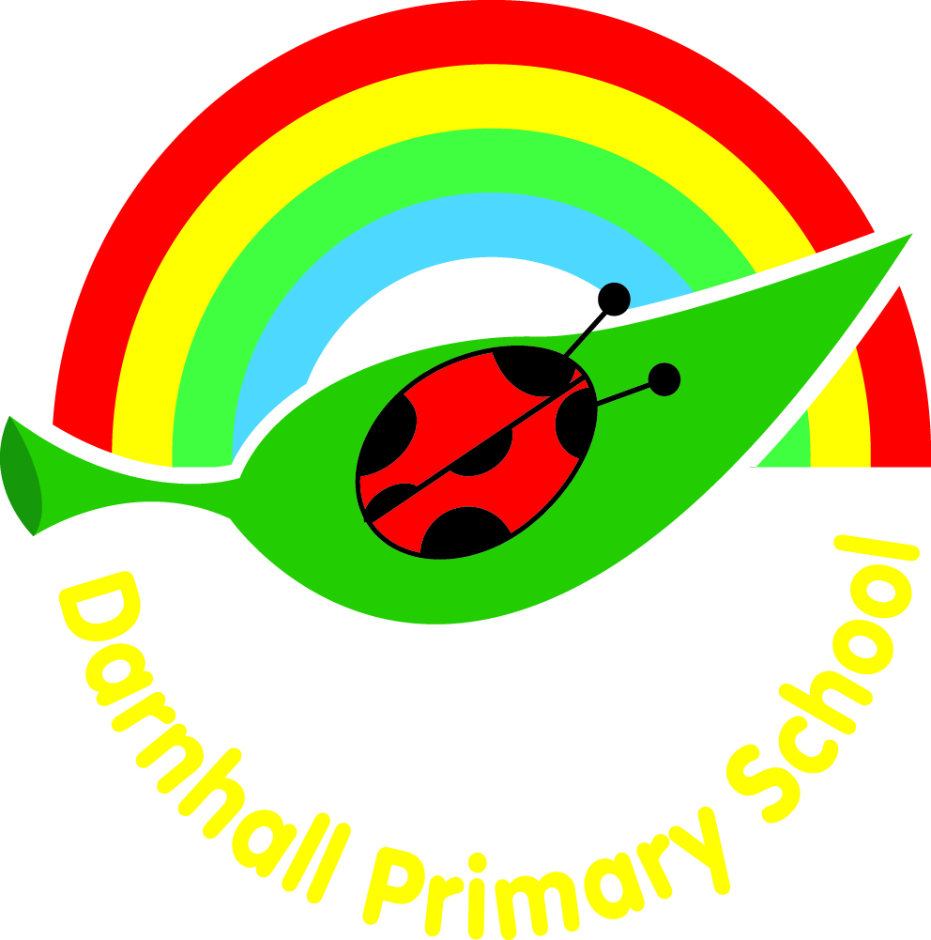
Darnhall Primary School

Science Policy

CONTENTS

Section

- Introduction
1.1 - Aims
- The science curriculum
2.1 - EYFS
2.2 – Key Stage 1 and 2
2.3 - Teaching and learning strategies for implementation
2.4- Continuity and progression
2.5 - SEN, equal opportunities and gifted and talented
- Organisation
- Assessment and recording
- Planning and resources
- Health and safety
- Staff development and training
- Role of science co-ordinator
- Policy Review

1 Introduction

Developing and increasing pupils’ understanding and enjoyment of science is core to our curriculum. This policy will put into place the provisions for science which are set out in the National Curriculum 2014. Science stimulates and excites pupils’ curiosity about phenomena and events in the world around them. Children learn to ask scientific questions and begin to understand the way in which science will affect their future on a personal, national and global level. Because science links direct practical experience with ideas, it can engage learners at many levels. Scientific method is about developing and evaluating explanations through experimental evidence and modelling. This is an ignition to critical and creative thought which is encouraged at Darnhall.

1.1 Aims

Teachers create a positive attitude to science learning within their classrooms and reinforce an expectation that all pupils are capable of achieving high standards in science. Our whole school approach to the teaching and learning of science involves the following;

- Preparing our children for life in an increasingly scientific and technological world.
- Helping our children acquire a growing understanding of scientific ideas.
- Helping develop and extend our children’s scientific concept of their world.
- To develop pupil’s enjoyment and interest in science.
- To develop positive attitudes which encourage collaborative learning and perseverance.
- Engage pupils as learners at many levels through linking ideas with practical experience.
- Fostering concern about, and active care for, our environment.

2 The science curriculum

2.1 EYFS

The Foundation Stage deliver science content through the ‘Understanding of the World’ strand of the EYFS curriculum. This involves guiding children to make sense of their physical world and their community through opportunities to explore, observe and find out about people, places, technology and the environment. They are assessed according to the new, Early Adopter’s EYFS framework.

2.2 Key Stage 1 and 2

Science is a core subject of the National Curriculum 2014 and pupils undertake science lessons every week in both Key Stage 1 and Key Stage 2. Science is allocated 1 hour a week in Key Stage 1 and 2 hours a week in Key Stage 2. Science objectives are covered throughout topics in each class. The working scientifically objectives are embedded throughout the year, linking with appropriate topics to ensure all areas are covered and progression of these skills is evident between year groups.

Children learn best in science through first hand experiences. Children also need opportunities to share what they know, ask questions to extend their own understanding and to reflect on their work and what they have learnt. Teachers will endeavour to provide practical experiences through which children can explore their ideas and develop their knowledge and understanding of science.

What should science look like?

- An active learning environment, showcasing children’s work and relevant scientific vocabulary on the working walls during science topic coverage.
- Children being encouraged to ask and answer questions and discuss their work and ideas.
- Children devising and conducting their own investigations within the context of the relevant curriculum content, as well as being given opportunities to develop their working scientifically skills.
- Children recording their findings in a variety of ways.
- Children showing enjoyment in the activities they are undertaking.
- Cross curricular teaching of science.

2.3 Teaching and learning strategies for implementation

Science is taught with an emphasis on the pupils engaging in practical enquiry to support/develop their understanding of scientific concepts and skills. Teachers use a range of strategies including: exploration, investigative enquiry and illustrative enquiry. Teachers try to ensure that some of the children’s ideas are used as a basis for enquiry.

The skills-based curriculum used develops scientific skills which include:

- Observing, exploring and ordering.
- Posing questions and devising experiments to answer these questions.
- Using equipment, including computers, correctly to test out theories, recording.
- Finding and analysing data.
- Evaluating evidence and presenting conclusions clearly and accurately.
- Interpreting findings critically.
- Communicating findings.

2.4 Continuity and progression

The school uses curriculum content maps in science which ensure progression throughout the school years and within year groups. The school ensures curriculum continuity by following the science units of work and by close liaison between staff at the planning stages. If a topic has been taught previously, the teachers can refer to the previous curriculum content map to ensure progression is taking place. This will ensure there is no repetition, only recapping and extending prior learning. Within year groups, the curriculum content maps ensure there is sequencing and progression throughout a science topic.

2.5 SEN, equal opportunities and gifted and talented

In school we aim to meet the needs of all our children by differentiation in our science planning and in providing a variety of approaches and tasks appropriate to ability levels. Planning at all levels ensures that all pupils’ interests are taken into account, as well as catering for the range of abilities and SEN within the class. Pupils use a variety of means for communicating and recording their work. All pupils, including those with special educational needs, undertake the full range of activities. Children that are gifted and talented in science are given extension work to challenge their thinking and understanding even further. Teacher assessment determines the depth to which individuals and groups go during each unit of work.

At Darnhall Primary School, we are committed to providing all children with an equal entitlement to scientific activities and opportunities regardless of race, gender, culture or class.

3 Organisation

Science will be planned and arranged into topic blocks by the class teacher, to have a project-based approach. There are set topics for each year group that can be covered at any point throughout the year either as a discrete subject or as part of a topic based unit.

Topics covered in each year group
Year 1 | Materials | Animals including humans | Plants | Plants (seasonal change) | Animals including humans
Year 2 | Materials | Animals including humans | Plants | Plants | Living things and their habitats
Year 3 | Animals including humans | Light | Rocks | Plants | Forces and magnets
Year 4 | Living things and their habitats | Animals including humans | Electricity | Sound | States of matter
Year 5 | Materials | Materials | Animals including humans | Space | Forces
Year 6 | Electricity | Living things and their habitats | Evolution and inheritance | Animals including humans | Light

Within classes pupils are taught as a class, within a group and individually according to the learning task. The class teacher will select the appropriate style / organisation to suit particular lessons / groups of pupils.

4 Assessment and recording

Children’s progress is continually monitored and is used to inform future teaching and learning. By the end of each key stage, pupils are expected to know, apply and understand the matters, skills and processes specified in the relevant programme of study as set out in the National Curriculum. These are set out as statutory requirements. We also draw on the non-statutory requirements to extend our children and provide an appropriate level of challenge. Children receive effective feedback through teacher assessment, both orally and through written feedback in line with the Can I? learning intention statement. Children are guided towards the achievement of the main objective through the lesson and have the Can I? statement to refer to in their books. Assessment for learning is continuous throughout the planning, teaching and learning cycle.

Children are more formally assessed half termly in KS1 and KS2 using a variety of methods, including but not limited to:

- Observing children at work, individually, in pairs, in a group, and in classes.
- Questioning, talking and listening to children.
- Considering work/materials / investigations produced by children together with discussion about this with them.

All new topics begin with an assessment of what the children already know, using the school’s science knowledge organisers. Children are involved in the process of self-improvement, recognising their achievements and acknowledging where they could improve and refer back to the original knowledge organiser, annotating what they now know at the end of the unit.

In the EYFS, we assess the children’s Understanding of the World according to the new Early Adopter Framework, focusing on the specific areas of Understanding of Expressive Arts Design as some aspects of this area are also science based.

5 Planning and Resources

Planning is a process in which all teachers are involved. Planning should be done with parallel teachers. All teachers have access to the ECM subject topic mats and curriculum content maps which outline key knowledge and skills to assist with planning.

We have sufficient, high-quality science resources to aid and support the teaching of all units and topics taught, from EYFS to Y6. We keep these in a central store, where they are labelled and easily accessible to all staff. We also have school grounds which provide an invaluable resource for science activities, especially for the study of Life and Living Processes. EYFS have a range of resources kept in classes, for simple access for children during exploration. The library contains a good supply of science topic books to support children’s individual research.

Any breakages/damage to equipment should be reported to the science coordinator who will make arrangements for repairing or replacing as appropriate. Where teachers identify a need for additional resources to support their science teaching, this should be reported to the science co-ordinator who will plan to obtain those resources within budget constraints. The school allocates an annual budget for science equipment. Teachers discuss needs with the science coordinator and Headteacher and ensure planned units of work are adequately resourced.

6 Health and safety

Safe practice must be promoted at all times. Teachers must also take into account the school's Health and Safety policy. Particular attention must be given to avoiding the use of anything that aggravates individual pupils’ allergies. Safety issues will have been identified in medium-term planning and risk assessments must be completed, when activities are identified that are unusual and beyond the scope of normal safety practice.

7 Staff development and training

The Headteacher discusses staff development needs and, where appropriate, these are built into the school’s development plan. The needs of individual members of staff (teaching and non-teaching) are identified as a result of the school’s performance management program. Staff attending training are expected to share the useful points with other relevant staff.

8 Role of the science co-ordinator

It is the responsibility of the subject leader to monitor the standards of children’s work. The subject leader is also responsible for supporting colleagues in their teaching, for being informed about current developments in the subject, and for providing a strategic lead and direction for science in the school. The subject leader monitors the budget, resources science topics and books trips and workshops to support learning. The subject leader has specially-allocated time for fulfilling the task of reviewing samples of children’s work, training, liaising with other subject leaders from other schools and organising science week.

The science coordinator will report to the Head Teacher and Governing Body.

9 Policy Review

This policy should be considered alongside other relevant policies. It will be reviewed by the governing body as part of its schedule of policy review.

